**Gabriel Sharepoint site(Questions and Comments)**

1. In our last styling to display vertical menu. I tried to make it vertical and every label is misplaced as shown in image. Although if I fix it, than we will have to compromise on font size that will contradict with style guide provided. Other thing is it the submenu items won’t collapse.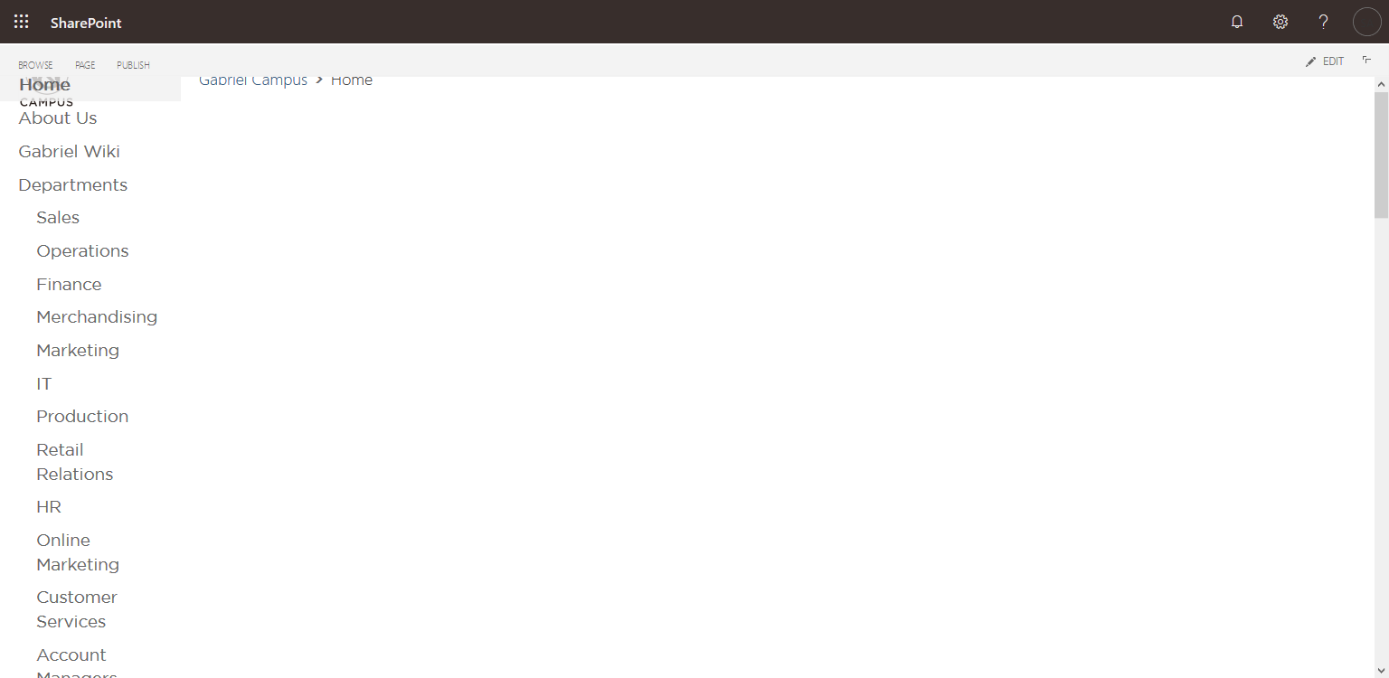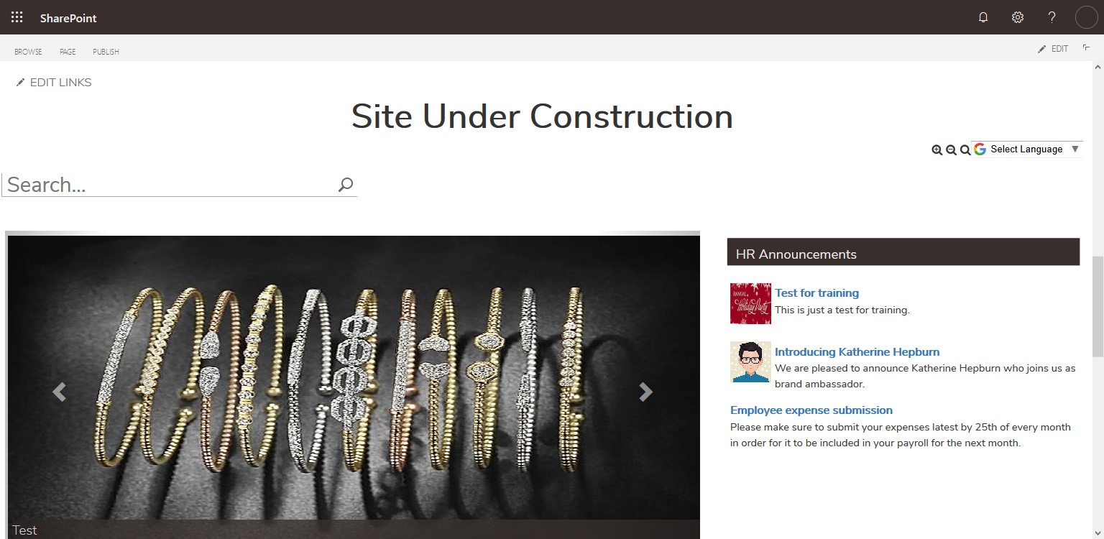

Fixing width will effect font size and other styles

Labels overlapping on logo and Home

Not collapsible

Top Margin issue

1. The logo issue will remain same with rectangular logo.
2. The events strip is not available with classic page and sharepoint do not support images in calendar.
3. The hidden calendar might need some extra work but it is doable. 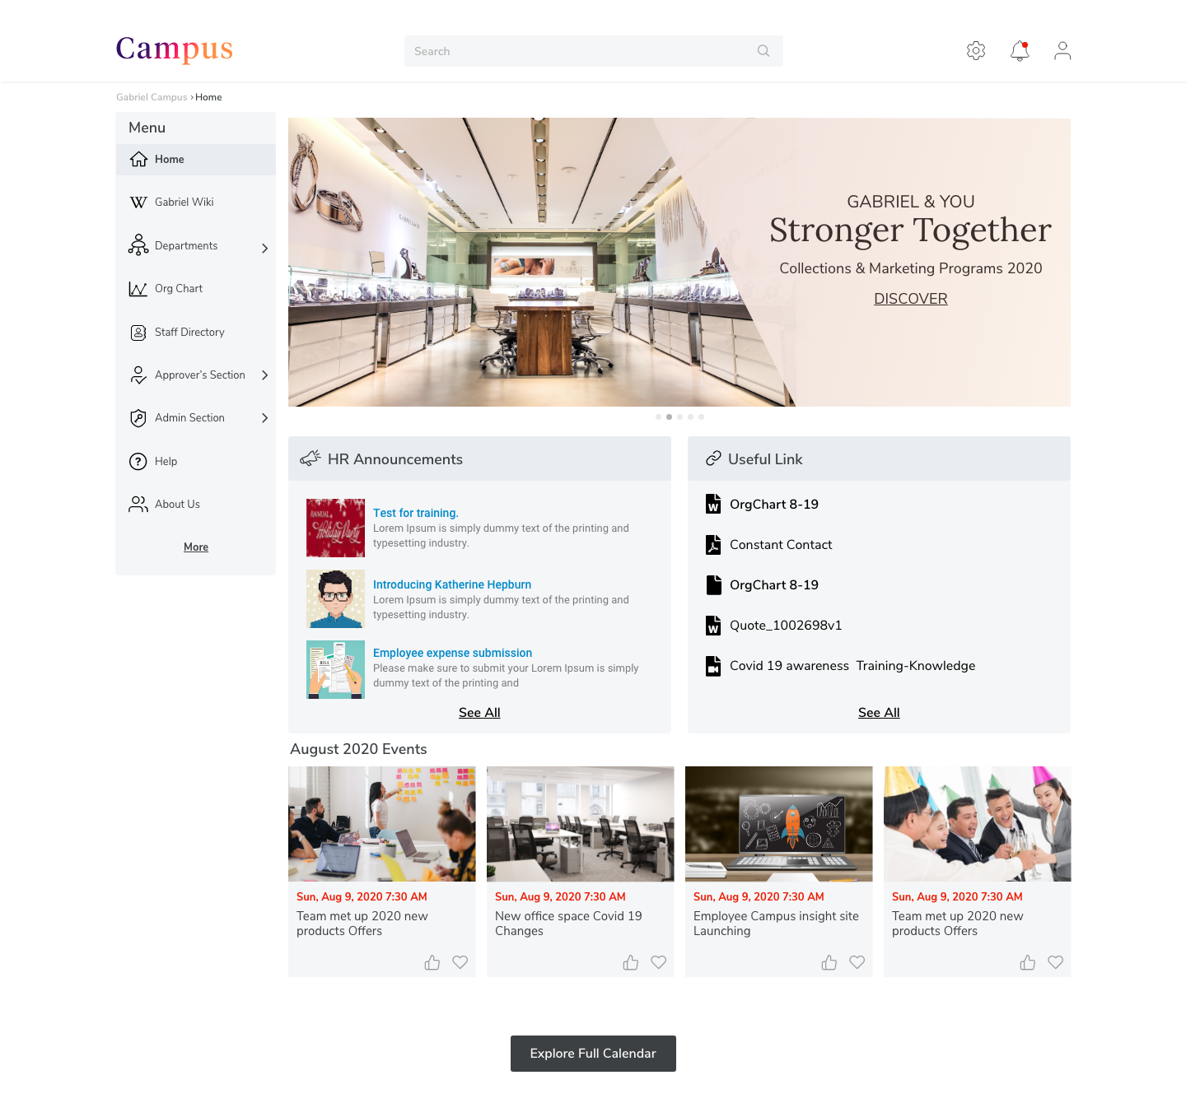

Search not supported here in classic pages.

Carousel or Banner?

Events like strip not supported in classic pages and images not supported with events

1. My question is the top image is a carousel image or a banner?
2. If it is banner than we have to remove carousel in that case?
3. The search bar will not go at top bar because it is set by sharepoint itself and only available in modern page.  Do we keep the search bar as it is or we shift to left or right?